**SHIMONI DEMONSTRATION SCHOOL-KIRA**

MID TERM II EXAMINATIONS, 2024

**P.1 LITERACY II**

Name:__________________________________________________

**SECTION A**

Fill in the missing vowels from 1-2

a, ____, i, ____, u

**Name the pictures by their last sounds.**

|  |  |  |
| --- | --- | --- |
| 3 | Z:\Collection\Printables\Newest\book 4555.png4. | 5. |
|  |  |  |

**Join the sounds to make one word.**

6. m-a-n- ______________ 7. r-oa-d- ________________

8. br-oo-m- _____________

**Tick ( ) the people found at school. (9-11)**

teacher, doctor, matron, cook

**Write the correct spelling**

12. snu nsu sun- _____________

13. cta, cat, tca - ______________

14. bus sbu bsu- ______________

**Draw the people found at home.**

|  |  |  |
| --- | --- | --- |
| 15. father | 16. mother | 17. baby |
|  |  |  |

**Show sounds in the word**

18. mat- _________________ 19. book- _____________________

20. girl- ____________________

 Count and write

21. __________________________________________

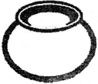

22, ____________________________

**Fill in the missing letter sounds.**

23. b ___ rn 24. f___ re 25. Sn_____ k______

**SECTION B**

26. **Read and draw the types of weather.**

|  |  |  |
| --- | --- | --- |
| Sunny weather | Rainy weather | Windy weather |
|  |  |  |

27. **Write words for the given sounds**

b - ______________ oo - ________________

ai - _______________ ee - _______________

28. Circle and write the syllable in the word

d r i v e - _______________ p a i n - ________________

n u r s e- ___________________

29. **Match the body parts to their uses.**

eyes feeling

nose tasting

tongue seeing

skin smelling

30. **Name these activities done at school.**

|  |  |  |
| --- | --- | --- |
|  |  |  |
|  |  |  |

31. What is this?

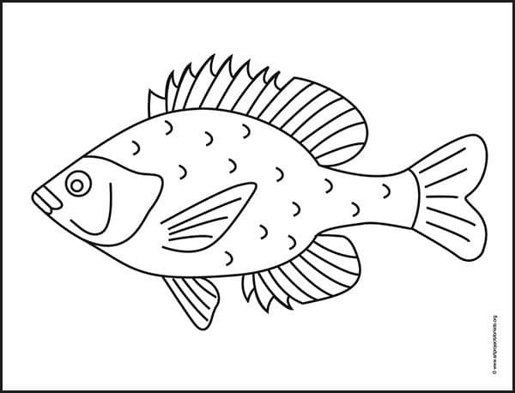This is a________________________________________________

Where does it live?

It lives in ____________________

32. **Circle the picture for the given sounds.**

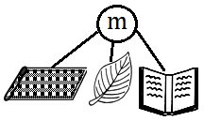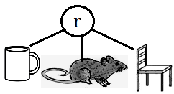

**33.** **Tom’s reading ladder**

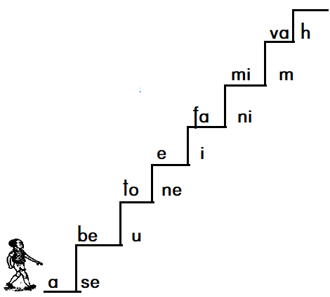

a) Write any four syllables from Tom’s reading ladder.

i) _______________________ ii) ______________________

iii) _____________________ iv) ______________________

b) Write any two consonants from Tom’s reading ladder.

i) ______________________ ii) _______________________

c) Give any two vowel sounds from Tom’s reading ladder.

i) _______________________ ii) _______________________

34. **Circle the correct word from the letters**.

f g m a n h k y

b o y t f c v m

x n b a y s g i r l

35. **Join the sounds to make syllables.**

f + e = ________________ t + i = ___________________

m + o = ________________ h + a = ___________________

36. **Fill in correctly**

Three plus two equal - ______________

Zero plus five equals - ______________

One plus one equals - ______________

37. Copy and write neatly (2marks each)

Dd Dd Dd Dd

G**g** G**g** G**g** G**g**

dog doll day drum

girl good guard

green grape grind

*******God Bless*********